Before starting the primary design, we researched the most commonly use HVAC control system used in our homes and office buildings.

# HVAC control system structure

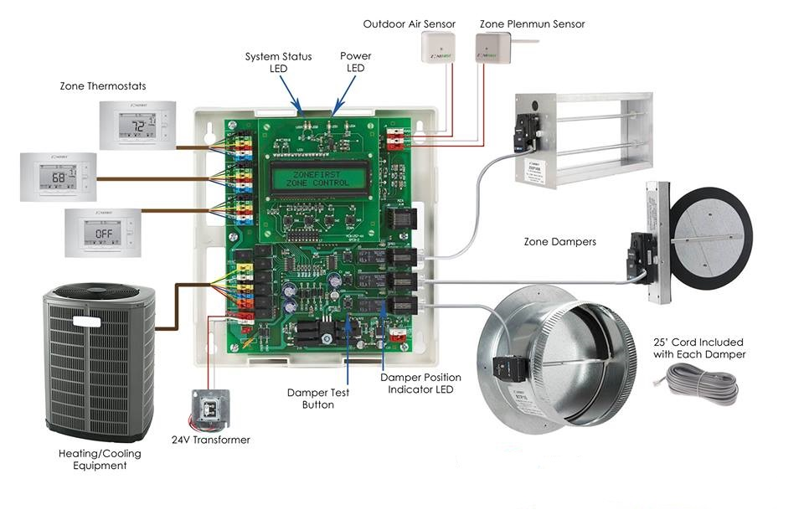

A typical HVAC control system contain three parts: thermostat, HVAC controller, HVAC actuators.

# Thermostat Functions

# C:\Users\Charlie\AppData\Local\Microsoft\Windows\INetCache\Content.Word\thermostat_b.jpg

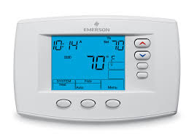

For a HVAC system with Heating/Cooling equipment, it has two modes to choose.  when our home is too cold, the thermostat switches on the heating so things quickly warm up; once the temperature reaches the level we've set, the thermostat switches the heating off so we don't boil. The cooling mode is opposite. You and also change the wind flow speed through a modern thermostat. So It has three main functions:

* 1. Heating indoor environment to set temperature
  2. Cooling indoor environment to set temperature
  3. Change Fun speed

# Thermostat connection

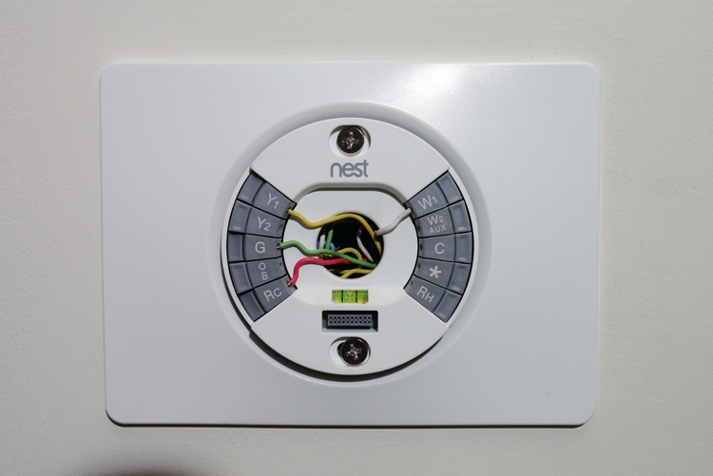

A typical connction for most Home and office building system, the function of wires:

**RC - Red Wire (Power 24 Vac)  
RH or 4 - Red Wire Jumpered (Power 24 Vac)  
W - White Wire (For Heating Enable)  
Y - Yellow Wire (For Cooling Enable)  
G - Green Wire (Controls Fan ON-Auto)**

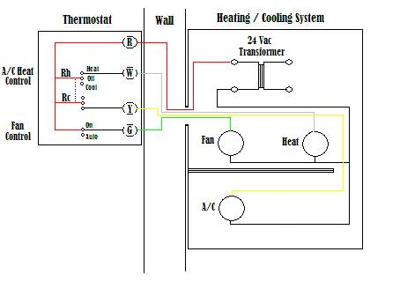

The diagram shows how the wiring works. However, your connections may seem a little different on the thermostat itself. The RED wire or 24 Vac power lead is connected straight to the RC & 4 terminals. Some thermostat units have a dedicated R terminal and it jumpers to the RC, RH or 4 terminals internally. The W, Y and G terminals should be pretty straight forward on most all types of thermostat's.